DATA MANAGEMENT SYSTEM

2 DMS PROJECT PHASE – I SPECIFICATIONS
2.1 Graphical User Interface

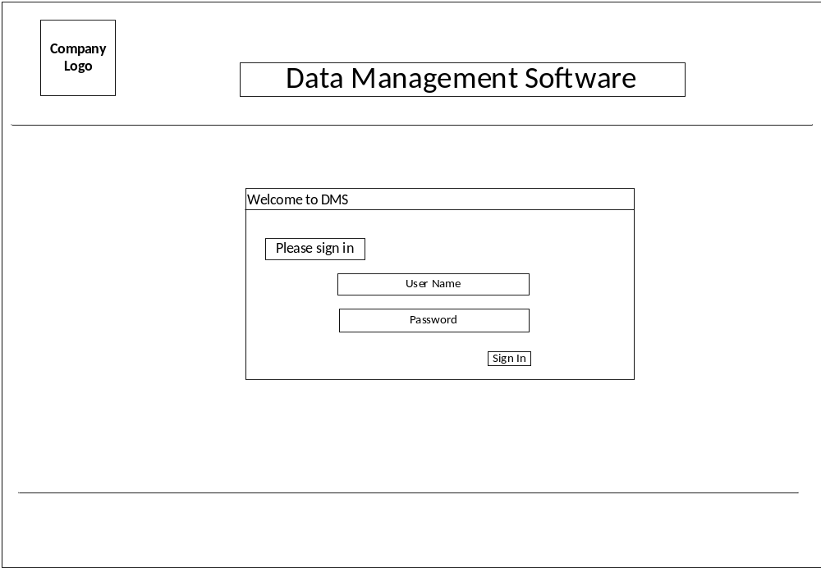
Figure 1: Page – 1 wireframe login page

This login page (no changes required), which takes the user name and password will then verifies the data with database and authenticates if matches.

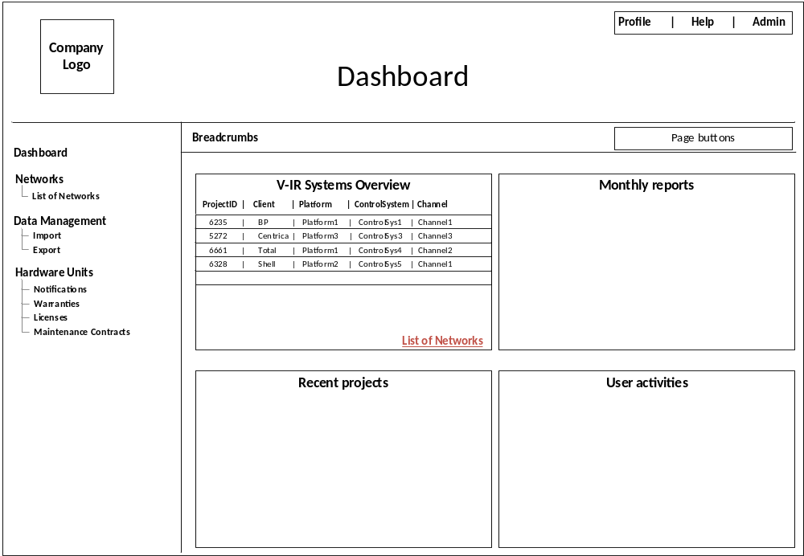
Figure 2: Page – 2 wireframe dashboard page

On the first box, mini version of ‘List of Networks’ page will be shown,
- Title ‘NetworkStatus’ changed to ‘V-IR Systems Overview’
- Small table with minimum information –‘1. ProjectID 2. Client 3. Platform 4. ControlSystem 5. Channel’-
- ‘List of Networks’ link at the bottom of the box, goes to ‘List of Networks’ page
- Each row should link to go to appropriate pages;
  - For example;
  - First project (#1) ‘6235’ has 2 nodes, second project (#2) ‘5272’ has 3 nodes, third project (#3) ‘6661’ has 1 node, fourth project (#4) ‘6328’ has 5 nodes.
  - Click on project #1, #2, #4 should go to ‘Network Image’ page and click on #3 should go to ‘Graph’ page
- Number of nodes will be identified from the column ‘vNetAddress’ of database table ‘product_data’

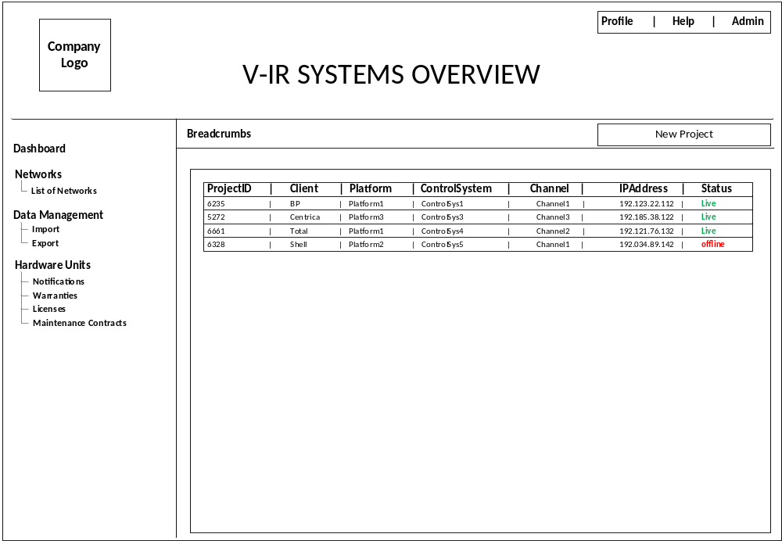
Figure 3: Page – 3, wireframe, list of networks

List of Networks page,
- ‘List of Network Units’ to be removed
- ‘Page buttons’ is replaced with ‘New Project’ button link will go to ‘Create Project’ page.
- Remove - Unit Serial#- ‘1. ProjectID, 2.Client, 3.Platform, 4.Control System, 5.Channel 6. IP Address, 7. Unit Serial#, 8. Status’ from the table.
- Each row should link to go to appropriate pages;
  - For example;
  - First project (#1) ‘6235’ has 2 nodes, second project (#2) ‘5272’ has 3 nodes, third project (#3) ‘6661’ has 1 node, fourth project (#4) ‘6328’ has 5 nodes.
  - Click on project #1, #2, #4 should go to ‘Network Image’ page and click on #3 should go to ‘Graph’ page
- Number of nodes will be identified from the column ‘vNetAddress’ of database table ‘product_data’

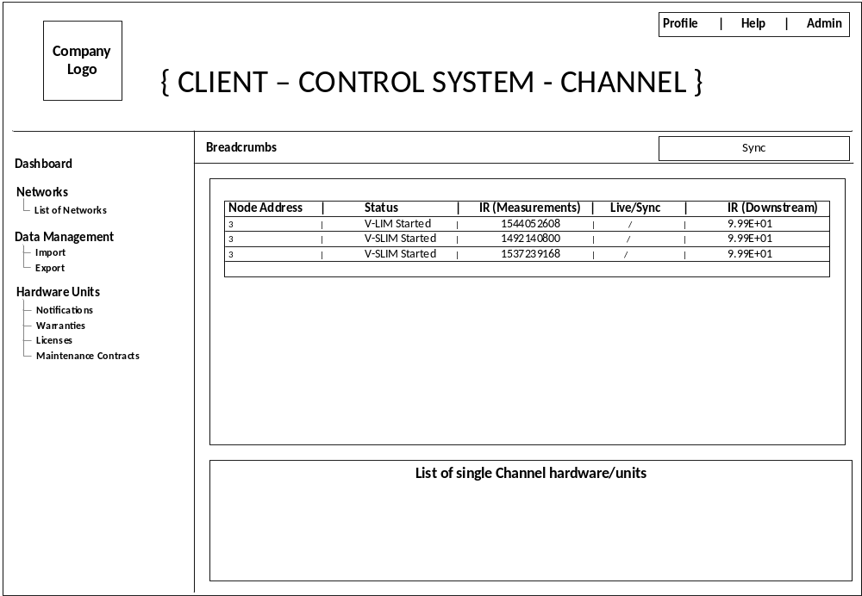
Figure 4: Page – 4, wireframe, list of network Image

Network Image page;
- Title of the page should be dynamically updated using the corresponding project selected from the previous page either from ‘List of Networks’ page or ‘Dashboard’ page
- ‘Sync’ is used to get the data from the unit and push into the database.
- Remove…
  - ‘Network Image’ name above the table
  - ‘Name: Total’ above the table
  - ‘Unit Serial#: 121297’ above the table
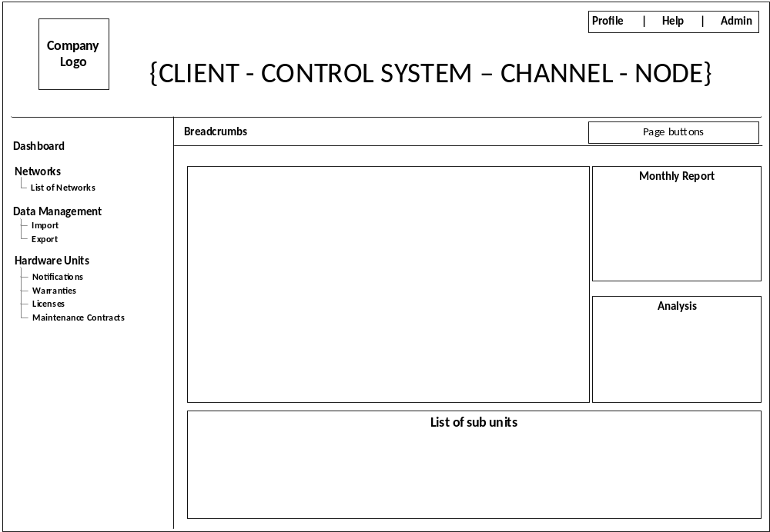
Figure 5: Page – 5, Wireframe Plotting IR graph
Graph page;
- Title of the page should dynamically updated based on { CLIENT – CONTROL SYSTEM – CHANNEL – NODE }
- Remove ‘Network Status Graph’ title above the graph

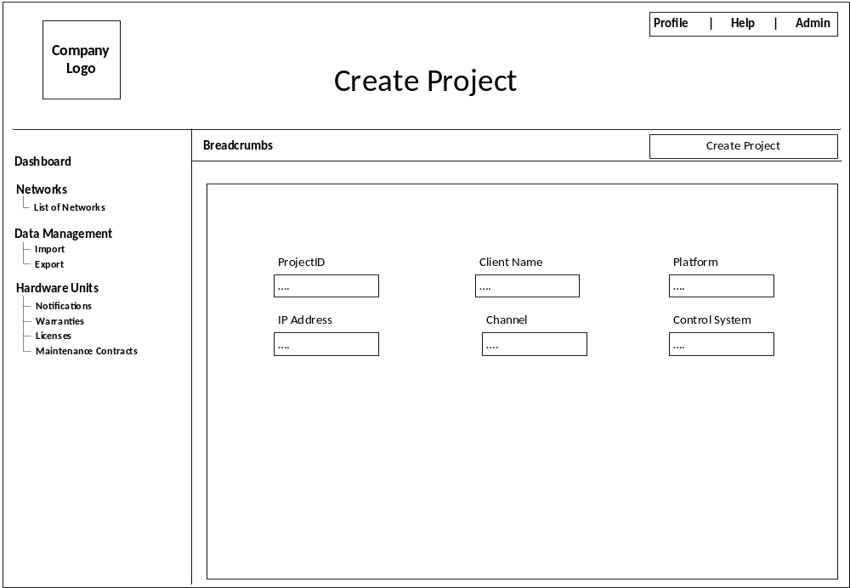
Figure 6: New Page-6, to create project

This page is used for create project, all the key project information are recorded in this page, these key information are used to identify the projects.

